*Mohamad Haziq Zikry Bin Mohammad Razak      -A20EC0079*

*Section 10*

*Lecturer's Name: Dr. Nies Hui Wen*

Lab Exercise 3: Associations, Aggregations, and Compositions (2.5%)

Instructions:

1. You need to put your name and the description of the program at the top of your \*.cpp file.
2. You are also required to give some comments regarding the program as your documentation.

Question:

Create a C++ program and complete the UML Class Diagram below.

The *Course* has a *Student*.

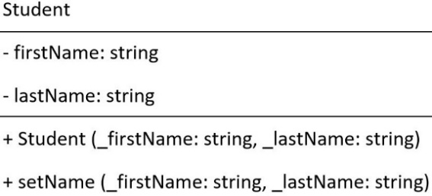

Answer:

